**Study Skills and Test taking Strategies for Success!**

In third grade we now have basic knowledge of core subjects and have achieved and or working towards reading at **grade** level.  
  
**Top Study Strategies for Parents and Students:**

* Set up a quiet **study** area.
* Plan a **study** schedule. ...
* Break **studying** into manageable chunks. ...
* Be flexible. ...
* Read & Review together.

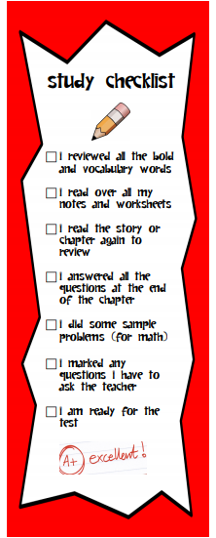

**Test taking Strategies**

Strategy 1: **Process of Elimination** This strategy shows you how to get rid of wrong answers and narrow down your choices. It’s easier to pick the right answer when you have fewer options to choose from.

Strategy 2: **Using Context Clues** This strategy teaches you how to spot clues in the test item that will help you figure out the answer. Clues can be hiding in the directions, the passage, or the answer choices.

Strategy 3: **Read the Questions and Answers** First This strategy helps you practice reading the questions and possible answers before reading a passage. Previewing the questions and answers helps you know what information to look for as you read.

Strategy 4: **Underlining Key Words** This strategy teaches you how to locate important information in the test item. Underlining these key words and phrases makes them easy to see and helps you focus on the best answer.

Strategy 5: **Plug-In** This strategy shows you how to “test out” each answer choice by plugging it into a sentence or phrase. You can then cross out answers that don’t make sense and find the answer that is the best fit.

Strategy 6: **Reread** This strategy reminds you to reread the directions, a passage, or the answer choices when you need to. Rereading can help you clarify a question or find information that you need in order to find the best answer.

Once you know how to apply these six strategies, you can use the one that will help you the most. You may also want to use two or three strategies together to find the best answer.

**Writing Response Strategies**

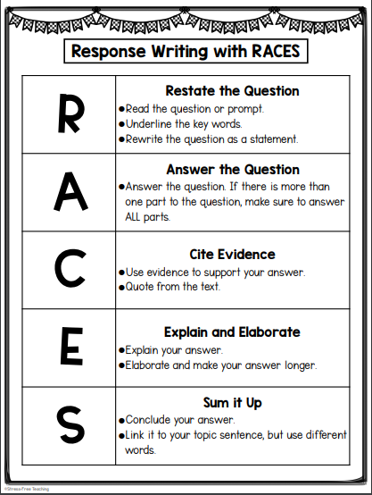

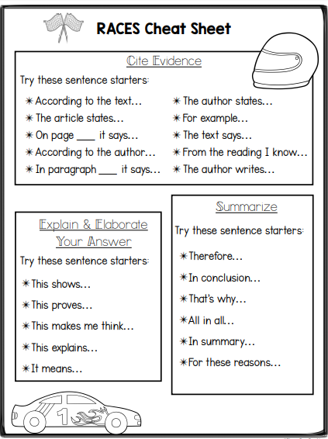

**Math Strategies**

